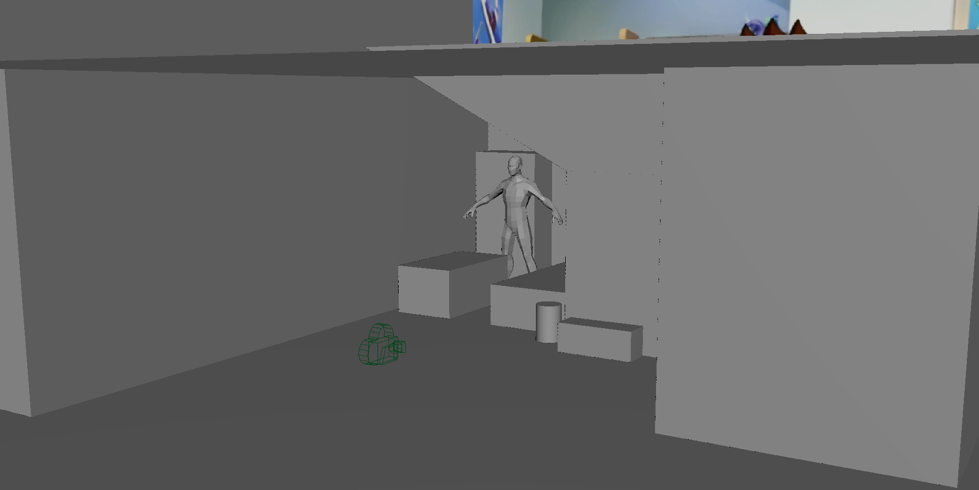
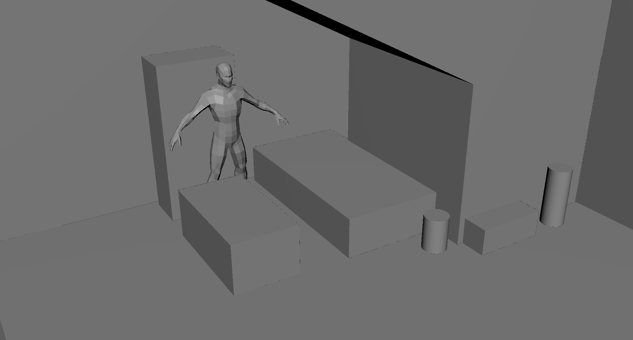
Learned how to use image projections as a reference for a rendered scene. I also learned how to mess around with the environment to match the perspective with the reference image, along with using a premade model for scaling those other objects. Accidentally messing up the render camera was not fun, especially when its transformations became weird enough that any movement can move it thousands of units. Finding out that I couldn’t undo those movements and resetting the camera’s position to get it back to where it was… wasn’t fun.
https://github.com/KiribosBriskit/DAGV-Projects

